Reading to your child is one of the best ways to put them on the road to success and demonstrates the value of reading and its importance. Read to your child every day because reading stimulates the development of the brain, language and builds a closer emotional relationship with your child. Take the time to ask questions, e.g. what do you think will happen next? Do you know what that word means? Which character is your favourite? You can have your child retell the story or make up a new one with the same characters.

Reading to children is so crucial that parents should find time to do it every day. Be creative at finding time to read aloud to your child. For example, read while waiting to see the doctor, at a restaurant, waiting in line at the store, or cooking dinner. You can read aloud in the morning before school and, of course, at bedtime. Read a story aloud while waiting for the bus or train or once aboard.

Older siblings, relatives, and friends may also enjoy reading aloud. When your child is ready, encourage him/her to read aloud to you and the rest of the family. This will pave the way for a love of reading.

Websites to Help Your Child with Reading

**Awesome site for beginner readers!**

www.starfall.com

[**Vowel Sounds**](http://www.bbc.co.uk/schools/wordsandpictures/cvc/crank/game.shtml) **and** [**Rhyming words**](http://www.bbc.co.uk/schools/wordsandpictures/cvc/whirl/game.shtml)

[www.bbc.co.uk/schools/wordsandpictures/cvc/crank/game.shtml](http://www.bbc.co.uk/schools/wordsandpictures/cvc/crank/game.shtml)

[**More Rhyming Words**](http://teacher.scholastic.com/activities/bll/reggie/index.htm)

[teacher.scholastic.com/activities/bll/reggie/index.htm](http://teacher.scholastic.com/activities/bll/reggie/index.htm)

[**Word Wall Words**](http://www.bbc.co.uk/schools/wordsandpictures/hfwords/starwords/game.shtml)

[www.bbc.co.uk/schools/wordsandpictures/hfwords/starwords/game.shtml](http://www.bbc.co.uk/schools/wordsandpictures/hfwords/starwords/game.shtml)

[**High Frequency Words**](http://www.sadlier-oxford.com/phonics/grade_k_1/high_fre/hifreq74.htm)

[www.sadlieroxford.com/phonics/grade_k_1/high_fre/hifreq74.htm](http://www.sadlieroxford.com/phonics/grade_k_1/high_fre/hifreq74.htm)

[**Alphabetical Order**](http://www.little-g.com/shockwave/library.html)

[www.little-g.com/shockwave/library.html](http://www.little-g.com/shockwave/library.html)

[**Find the Word**](http://www.uptoten.com/kids/kidsgames-mixedbag-hangman.html) [www.uptoten.com/kids/kidsgames-mixedbag-hangman.html](http://www.uptoten.com/kids/kidsgames-mixedbag-hangman.html)

[**Rhyming words**](http://www.bbc.co.uk/schools/wordsandpictures/cvc/whirl/game.shtml)[www.bbc.co.uk/schools/wordsandpictures/cvc/crank/game.shtml](http://www.bbc.co.uk/schools/wordsandpictures/cvc/crank/game.shtml)

[**Vowel Phonemes**](http://www.bbc.co.uk/schools/wordsandpictures/phonics/sandcastle/flash/game.shtml)[www.bbc.co.uk/schools/wordsandpictures/phonics/sandcastle/flash/game.shtml](http://www.bbc.co.uk/schools/wordsandpictures/phonics/sandcastle/flash/game.shtml)

[**Spin and Spell**](http://www.spinandspell.com/game.swf)

[www.spinandspell.com/game.swf](http://www.spinandspell.com/game.swf)

[**Children's Stories Online**](http://www.magickeys.com/books)

www.magickeys.com/books

**B.B.C. Read Alouds**

[www.bbc.co.uk/schools/laac/menu.shtml](http://www.bbc.co.uk/schools/laac/menu.shtml)

**A Children’s Digital Library**

[www.storyplace.org/storyplace.asp](http://www.storyplace.org/storyplace.asp)

Supporting Family

Literacy

#### The Importance of Reading to Children

*“A good book on your shelf is a friend that turns its back on you and remains a friend.”*

## Melissa Gaffen

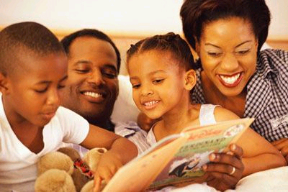

**How to Listen to Children Read**

Choose a good time and place -a quiet place without distractions.



Relax - make it fun and enjoyable



Talk about the book first - read the title, look at the pictures, make predictions about what the story might be about etc.



As they read, allow the child to struggle through an unfamiliar word first before intervening. This provides your child the chance to rely on the meaning of the sentence, their phonemic awareness and sounding letters out.



Encourage your child and praise them - the purpose is to help, encourage and build confidence. Make this a positive experience so your child develops a love of reading.



Don’t feel that you need to correct every error. Listening to a child read is not just an accuracy test.



Don’t make the sessions too long. Short sessions help maintain the child’s interest.



***What if my child makes a mistake when reading?***

* After your child makes a mistake wait for about 3 seconds and say nothing, they may self-correct.
* If your child doesn't self-correct, either give them the word or offer a prompt (e.g. give them the sound that they are struggling with; help them sound it out; get them to re-read the sentence).
* Encourage your child by praising the fact that they have finished the page, had a go at a difficult word, had no or few errors, read fluently, and seemed to understand what it was about.

**Great Read Alouds for your Child**

How do you know what books to read to your child? Choose a book that is meaningful and interests the child. Your will be motivated to read if he/she is interested in the topic. You can always have your child choose from a range of books themselves. Here are some great read alouds for children from Grades K-3.

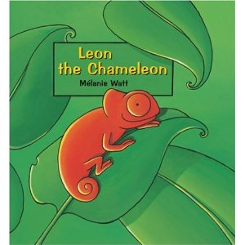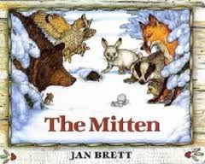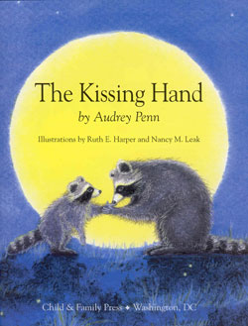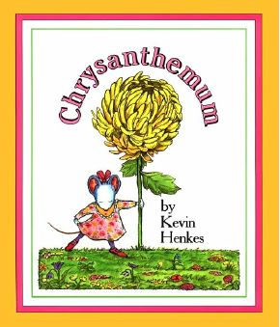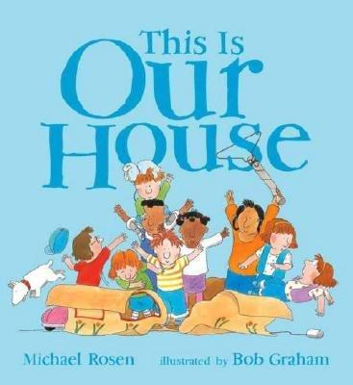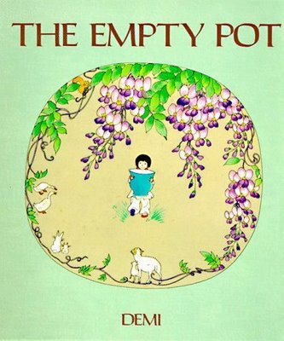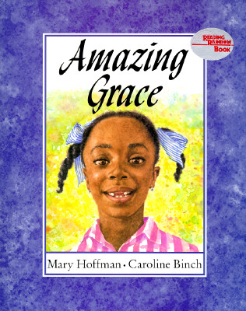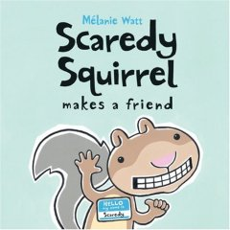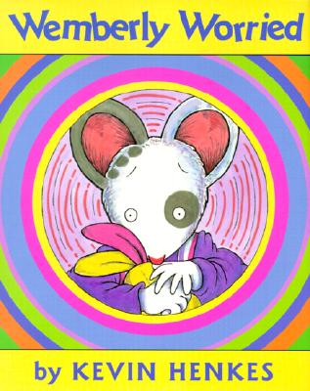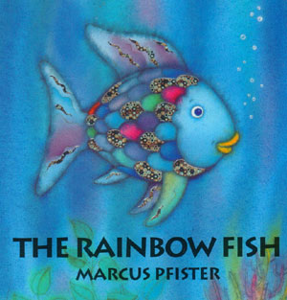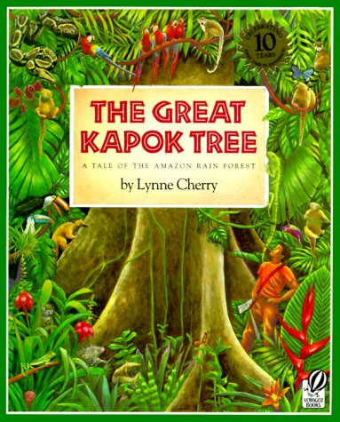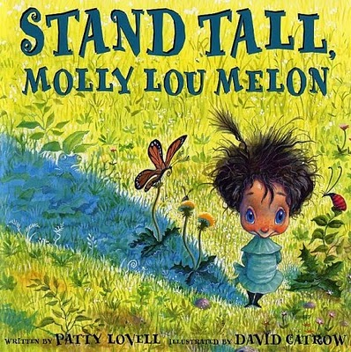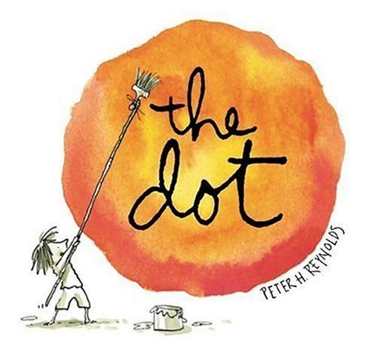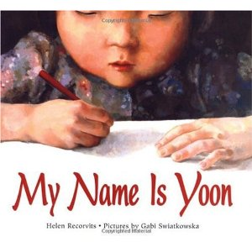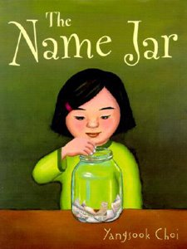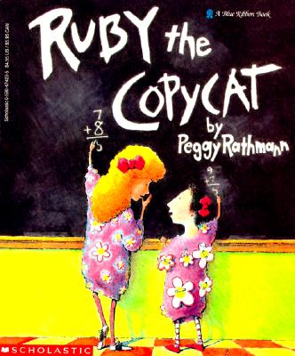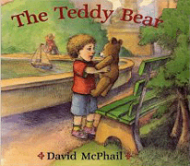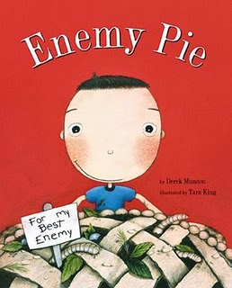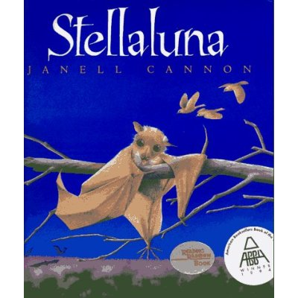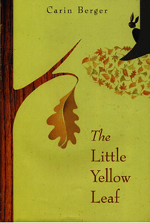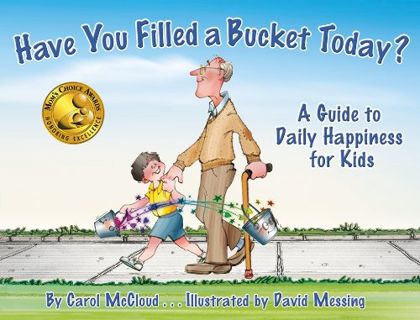

**Activities you can do at home that promote reading**

* Join a library reading club or story time. Make sure everyone in your family has a library card and schedule regular trips to the library.
* Set aside a certain time every day for reading. This helps to get kids in the habit.
* Play board games and have your child read the play cards in the game
* Flash Cards (i.e. sight words)
* Have your child practice their reading to a younger sibling or a stuffed animal
* Read yourself to show that you are an avid reader and excited about reading. When your kids see you reading they will want to follow your example. Actions speak louder than words.
* Make story strips- use sentence strips to sequence the events in a story
* Beach ball Comprehension- Use an actual beach ball and write comprehension questions on it (ex. What is the title? What is the setting? Etc.)
* Chalk and Sock- have your child write word families on a small chalkboard (ex. dog, hog, frog, log, etc.)
* Start reading to your children when they are young. Don't stop reading to your children as they grow older. You will both enjoy the chance to do something together.
* Give books as gifts then find a special place for your children to keep their own library.
* Make reading a privilege. Say, "You can stay up 15 minutes later tonight if you read in bed." or "Because you helped with the dishes, I have time to read you an extra story."
* Use humour. Here are some examples of humorous books for children: *Scaredy Squirrel, Captain Underpants, Diary of a Wimpy Kid, Memoirs of a Goldfish,* any *Robert Munsch* books*, Interrupting Chicken*